Daily Routine

A - Translate the following expressions into your own language.

Wake up = | Leave home = | Talk on the phone = | Watch TV =
Get up = | Go to work= | Read the newspaper = | Play computer game=
Get dressed/put the shoes on = | Arrive at work = | Feed the cat/dog = | Surf the net =
Go to the bathroom = | Start work = | Read = | Update my status on the facebook
Have a shower = | Finish work = | Write = | Check my e-mail =
Brush my teeth = | Go to the Gym = | Do the housework = | Get undressed =
Comb my hair = | Come back home = | Vacuum = | Say the prayers =
Have breakfast = | Cook dinner = | Wash the dishes = | Go to bed =
Make the bed = | Have lunch/dinner | Walk the dog = | Go to sleep/fall asleep =

B – Read about Mr Stuart’s routine and fill in the blanks with the Simple Present of the verbs in brackets.

Mr Stuart (1) _______________ (be) always busy. He usually (2) _______________ (get) up at 7am and he never (3) ______________ (eat) breakfast before taking a cold shower.
He often (4) ______________ (have) cornflakes, scrambled eggs, toast and tea for breakfast. Then he (5) _____________ (go) for a quick walk and (6) _______________ (buy) the newspaper. He never (7) _______________ (read) it until after lunch. At 9am he (8) ______________ (sit) at the piano and (9) ______________ (play) for three hours. He (10) ______________ (make) a lot of noise but his neighbours (11) ______________ (like) the music.
At 12 he (12) ______________ (watch) the TV news. 30 minutes later, he and his wife (13) ______________ (have) lunch. It (14) _______________ (be) a light meal. After reading the newspaper he plays the piano again. At 7pm all the family (15) _______________ (have) dinner. They (16) _______________ (eat) meat or fish, some vegetables and (17) _______________ (drink) wine. The children also (18) ______________ (have) soup and drink water. For dessert they usually (19) ________________ (eat) fruit, except at weekends. Every Saturday Mrs Stuart (20) ______________ (bake) a big cake!
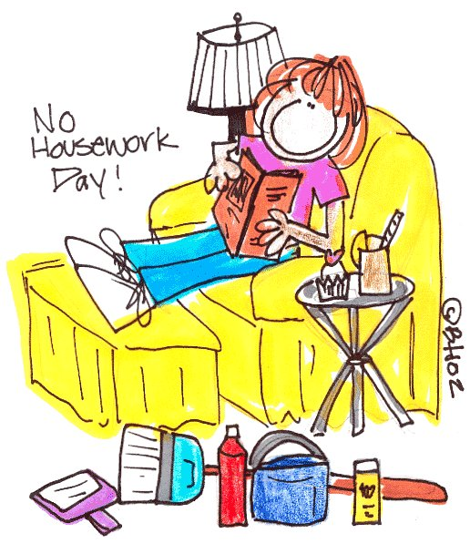
Before concerts Mr Stuart (21) ______________ (not/have) dinner. He only (22) ________________ (drink) milk or juice.

C – Write about your daily routine at weekends.

Key
B –
1 – is | 12 – watches
2 – gets | 13 – have
3 – eats | 14 - is
4 – has | 15 – have
5 – goes | 16 – eat
6 – buys | 17 – drink
7 – reads | 18 – have
8 – sits | 19 – eat
9 – plays | 20 – bakes
10 - makes | 21 – doesn’t have
11 – like | 22 - drinks

